AB Baikie Elburne Alexander  Rank: Able Seaman  Regimental Number: 10772-H  Born: Oct 25, 1931 Hamilton, Ontario  Discharged: Killed In Action  Served In: Korea Service: RCN (Royal Canadian Navy) Battle Group: United Nations Command (UNC) Regiment: HMCS Iroquois Korea Service Badge 1950 - 1953  Service Details :  Service Notes:  Enlisted: February 15, 1949 Hamilton, Wentworth, Ontario  Pre/Post War:  Deceased: October 02, 1952 at Korea  Cemetery: YOKOHAMA War Cemetery, Japan  Obituary: Son of Mrs. Bertha (Chalmers) of Hamilton, Ontario. Able Seaman Baikie is also commemorated on the Korean War Memorial at the Naval Museum of Alberta at HMCS Tecumseh in Calgary, Alberta. Half brother to James Clifford McGregor and Mrs. Rosetta Irena Weshart.  The medals and information on this page have not been verified by Family, Friends or historical document. To help us make this page more accurate and complete please email info@RememberNovember11.com to request any changes or to help us verify any medals or commendations.  AB Elburne Alexander Baikie on other official websites  Canadian Virtual  War Memorial  Researched By: Sean Wilson | 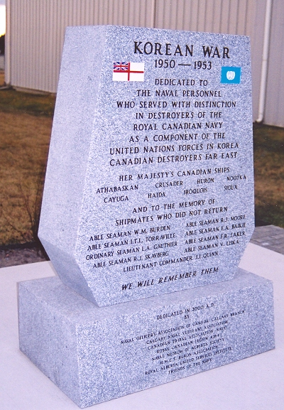  AB Elburne Alexander Baikie  Printable Version  Medals and Commendations  (In Order):  United Nations Service Medal Korea  Canadian Korea Medal  Canadian Volunteer Service Medal for Korea  Page from "Book of Remembrance"  (Click to Enlarge)  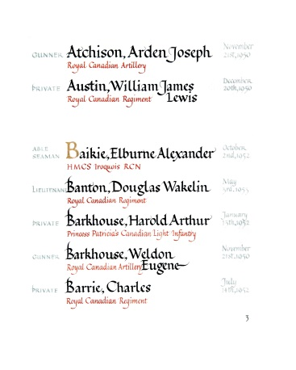  Clicking Thumbnail will enlarge image  